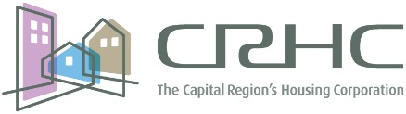

The July 26, 2016 Capital Region Housing Corporation Board Meeting has been postponed to
August 23, 2016

